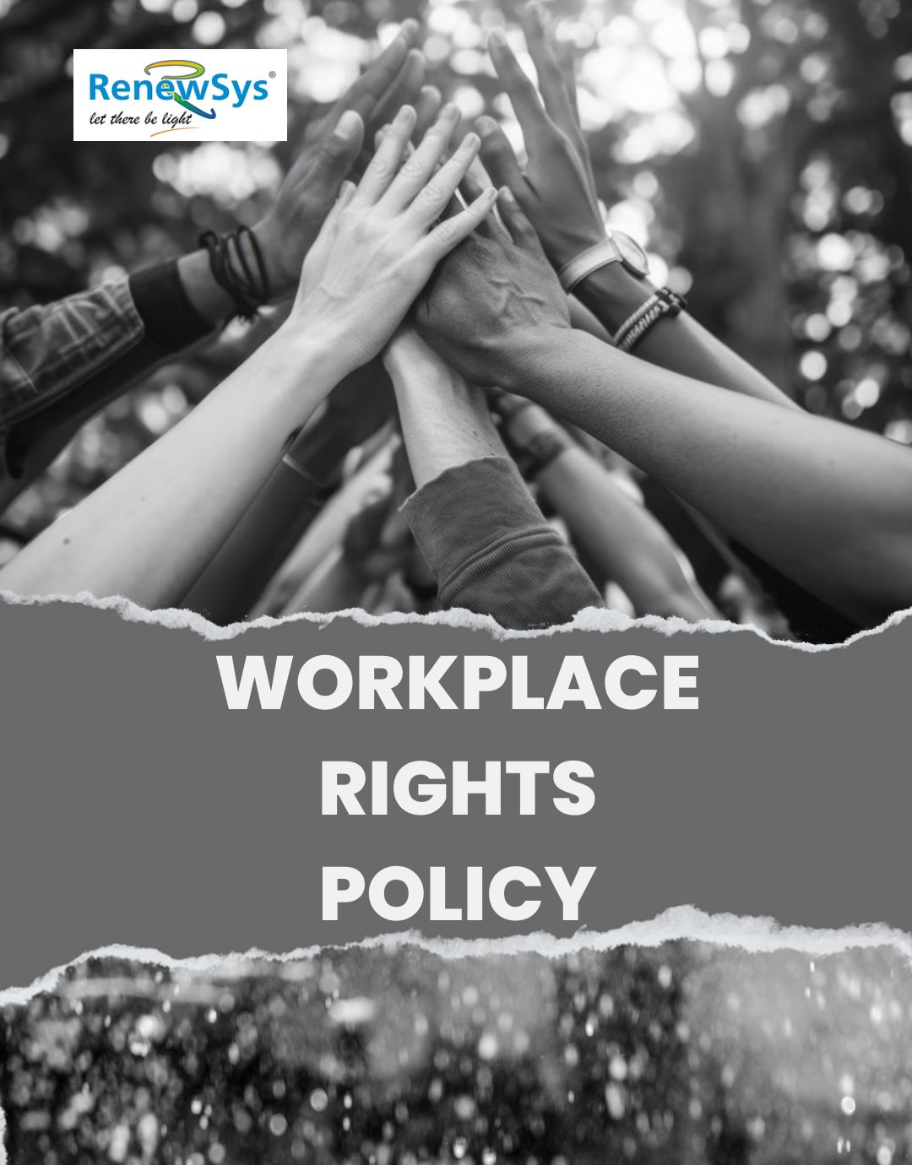

TABLE OF CONTENTS
PREFACE 2
SCOPE 2
POLICY DECLARATION 2
INITIATIVES AND TARGETS IN ALIGNMENT WITH SDGs 3
PERFORMANCE REPORTING 4
REPORTING STRUCTURE AND FREQUENCY 5
REVIEW MECHANISM 5

PREFACE

At RenewSys India Pvt Ltd., we recognize that labor rights, human rights, and worker health and wellness are fundamental to the long-term success of our business. We are committed to foster a sustainable workforce that is engaged, stable, and aligned with our organizational goals and values. We respect and safeguard the rights of our employees across all operations and within our business partnerships, ensuring fair working practices and a culture of respect.

Our policy is built on the principles of Internationally recognized frameworks, including the International Bill of Human Rights, the International Labour Organization’s Declaration on Fundamental Principles and Rights at Work, and the Children’s Rights and Business Principles. These standards guide our approach to protecting the rights and well-being of every individual within our organization.

SCOPE

This Policy is applicable to following sites and all of its employees, workers, sub-contractors and other stakeholders:

Sr. No. | Site | Address
1 | RenewSys India Pvt. Ltd. | Unit No 607, 6th Floor, Trade Centre, Bandra Kurla Complex, Bandra East- 400051 Mumbai, Maharashtra India
2 | RenewSys India Pvt. Ltd. | Plot No. E-141, Additional Patalganga MIDC Industrial Area, Village - Karade Khurd, Taluka Panvel, District Raigad, Maharashtra - 410 206, India.
3 | RenewSys India Pvt. Ltd. | Plot No. 6, Survey # 114/P,  Srinagar Village, Maheshwaram Mandal, Rangareddy Dist. - 501 359,Telangana, India.

POLICY DECLARATION

We are committed to ensuring fair treatment, safety, and respect for all employees, while preventing labor abuses and promoting diversity and inclusion. Through continuous improvement, teamwork, and training, we enhance labor relations, employee well-being, and health and safety. Compliance with all labor laws and human rights standards is a priority, with 2022-23 as our baseline year for tracking progress and driving measurable improvements across our operations.

INITIATIVES AND TARGETS IN ALIGNMENT WITH SDGs

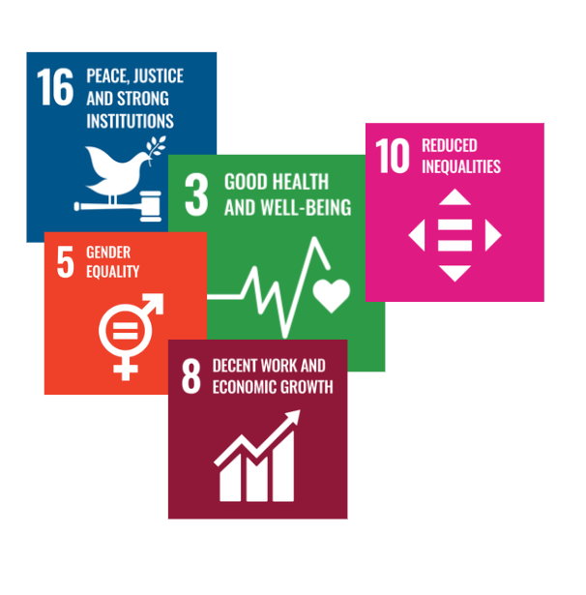

- Strengthen emergency preparedness through annual on-site and off-site emergency drills, ensuring employees are trained to respond effectively to unforeseen hazards.
- Increase employee involvement in safety initiatives by forming active safety committees at each location and encouraging two-way communication on health and safety concerns.
- Maintain zero lost time injuries across all plant locations by 2029-30, through proactive safety measures and continuous monitoring.
- Maintain the practice of Equiping 100% of employees with all required personal protective equipment (PPE) that meets safety standards by 2029-30.
- Reduce the required overtime hours to below 10% of total working hours by year 2029-30.
- To regularly assess and upgrade workplace ergonomics, providing employees with comfortable and safe workstations, including ergonomic chairs, desks, and equipment to reduce physical strain.
- Achieve 100% compliance with collective bargaining agreements by year 2029-30.
- To focus on establishing regular dialogues with employee representatives to address concerns and foster collaboration.
- Offer training programs to 90% of employees annually.
- Fill at least 50% of leadership positions through internal promotions by Year 2029-30.
- To launch a mentorship program to support the career progression of junior staff and high-potential employees.
- Conduct 100% supplier audits annually to ensure compliance with child and forced labor prevention policies and hence maintain zero reported cases of child or forced labor in our supply chain.
- Partner with NGOs and industry initiatives to raise awareness and drive systemic change against child and forced labor.
- Increase the representation of women in leadership positions by 30% by 2030.
- To follow targeted diversity hiring initiatives to increase representation of minority groups, women, and individuals with disabilities across all levels of the organization.
- Engage with external stakeholders, including NGOs and local communities, to collaborate on human rights initiatives.
- Establish regular reviews of external partner practices to ensure alignment with our human rights commitments.
- Engage 80% of Key External Stakeholders in Human Rights Dialogues by year 2029-30.

PERFORMANCE REPORTING
We at RenewSys India Pvt. Ltd. are committed to maintain transparency and accountability in the implementation of our Labor and Human Rights Policy. The progress of our initiatives will be reported annually through a detailed performance report which will include key performance indicators (KPIs) that are aligned with both the quantitative and qualitative targets set forth in this policy, offering a clear evaluation of our achievements, challenges, and areas for improvement.
Our reporting will cover a wide range of topics, including:
- Progress on employee health and safety initiatives
- Compliance with working conditions and labor relations standards
- Child labor and forced labor prevention measures
- Diversity, equity, and inclusion programs
- External stakeholder engagements on human rights
Additionally, the results of our annual employee satisfaction surveys, supplier audits, and safety assessments will be published by the HR Department and made available to all stakeholders, including employees, trade unions, suppliers, and external partners, ensuring that they are informed and engaged in our efforts to uphold human rights and fair labor practices.

RESPONSIBILITY
The Human Resources (HR) Manager will be responsible for compiling and preparing the annual labor and human rights performance report. This will be done in coordination with:
- The Safety and Health Officer for health and safety metrics
- The Supplier Relations Team for supplier audits and compliance data
- The Diversity and Inclusion Council for reporting on inclusivity efforts
- The Labor Relations Committee for progress on labor relations and grievance handling

REVIEW MECHANISM

Our Workplace Rights Policy will be reviewed annually by the Human Resources Manager to ensure accountability and transparency. This review will assess compliance with the policy, evaluate its effectiveness, and incorporate feedback from audits and stakeholders. Necessary updates will be made to maintain alignment with best practices, legal requirements, and the organization’s objectives.

REV. No. 01

EFFECTIVE FROM: 01.05.2024 NEXT REVIEW DATE: 01.05.2025
APPROVED BY:

